America’s White Table
By Margo Theis Raven
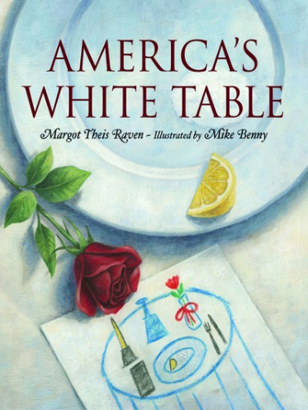
The book tells the story of a little girl who helps her mother set out a remembrance table in her home and how the sight brings tears to the eyes of her uncle, who served in Vietnam. The table includes reminders that many soldiers are unable to join family dinners. Setting an empty, white table actually is an established custom among military families but unfamiliar to many others.
* The small table symbolizes one soldier's lonely battle against many.
* The white candle stands for peace.
* The white cloth honors a soldier's pure heart when our country calls to duty.
* The lemon reminds us of a captive soldier’s bitter fate.
* The salt represents the tears of families waiting for his return.
* The empty chair symbolizes the missing soldiers.
* The turned-over glass symbolizes the meal that won't be eaten.
* The black napkin represents the sorrow of captivity.
* The red rose and ribbon stands for the hope that all missing soldiers will return someday.

