Students learn local history

Local historian Jerry Bourgain spoke to fifth graders during library storytime Sept. 29 about the history of the Sterling Ice Cream company. Bourgain brought historical photos and artifacts including Sterling Ice Cream cartons, canisters that were used to ship the ice cream by train, and even signage used in Sterling to tell the ice delivery person how much ice a household wanted.
After the presentation, students were treated to ice cream provided by Dairyland. The visit was coordinated by Main Street Sterling Director Stacy Clark.

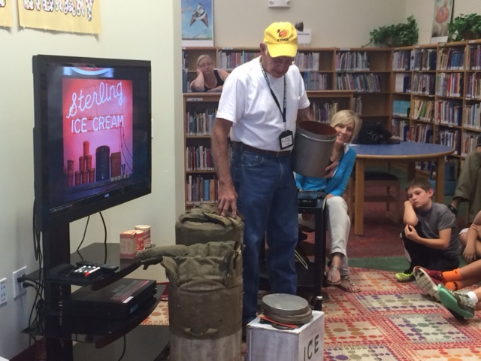
Local historian Jerry Bourgain holds a shipping container used by Sterling Ice Cream during a presentation to 5th graders while Stacy Clark, director of Main Street Sterling, looks on.

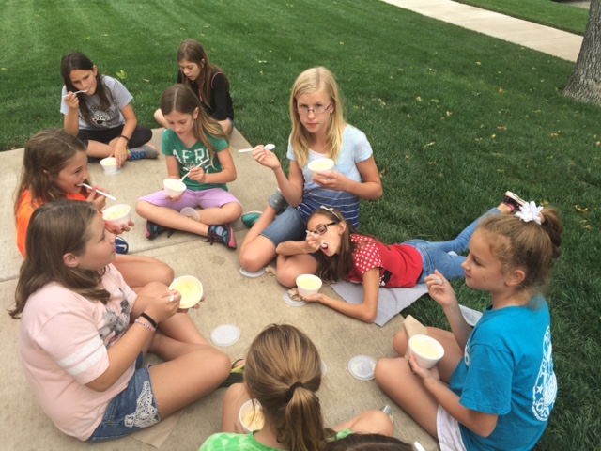
Fifth graders enjoy ice cream donated by Dairyland after learning about the history of the Sterling Ice Cream company.

