PRESCHOOL LIBRARY CHECK OUT
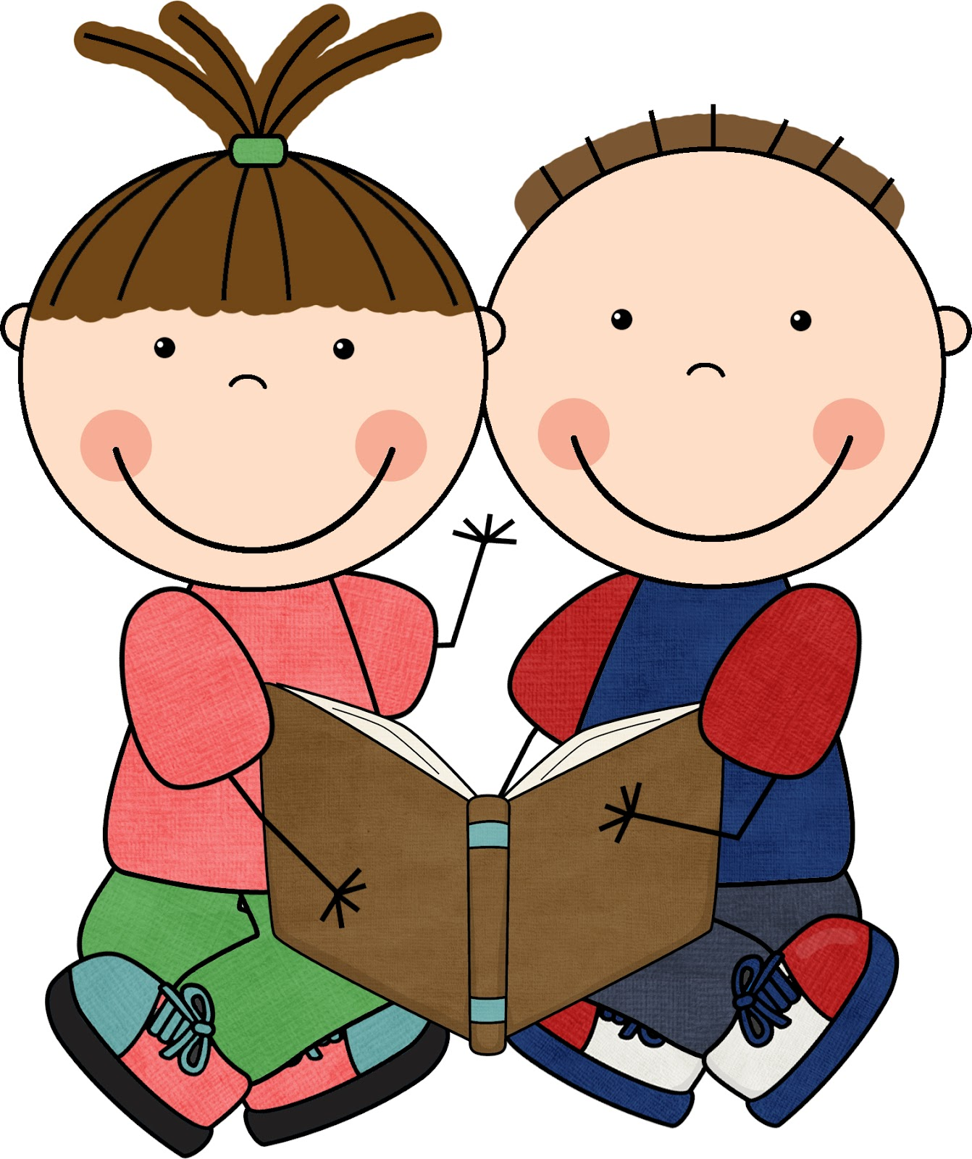
Now that we are feeling comfortable with the basic routines of school, preschoolers will have the opportunity to check out books from the Sterling Grade School Library.
The preschoolers will be able to borrow a book for one week. (It may be returned earlier.) After a book is returned, the student may check out another book. It is the responsibility of the parents to read the book to the student and return the book to the library in good shape. If a book is damaged or lost, you will be required to pay the replacement cost of that book. Depending on the age of the book and whether it is a hardback or paperback, replacement costs could range from $4-$25.

This is a learning opportunity for your child in many ways. Showing interest in books and reading to your child is the best way to influence their future reading ability. This also teaches them responsibility.
If you would like your child to be able to check out books from the library, please sign the form at the bottom of this page and return it to the teacher.
If you have any questions, please call Darby Strawn at 278-3112 during school hours.
BOOK CARE TIPS:

- Find a special place to keep your library book so it does not get lost (I suggest their backpack).
- Protect your library book from pets, younger brothers and sisters, and the weather. Your backpack or the classroom is the safest place.
- Let the librarian repair loose or torn pages in a library book (just let us know it needs repair when you bring it back).
- Remember to return your library book on time. You may keep it for 1 week.

***************************************************************************************

I give permission for my student _________________________________________________ to check out books and materials from the Sterling Grade School Library. I agree to be responsible for paying for lost or damaged items.

Parent/Guardian signature____________________________________ Date____________

